Was the Fall of Rome Inevitable?
YES
You decide…

Many historians believe that the decline and fall of the Western Roman Empire could not have been avoided. The problems the empire faced were too great. A famous 18th century historian of ancient Rome, Englishman Edward Gibbon, wrote
“…the decline of Rome was the natural and inevitable effect of
immoderate greatness. Prosperity ripened the principle of decay;
the causes of destruction multiplied with the extent of conquest;
and, as soon as time or accident had removed the artificial supports,
the stupendous fabric yielded to the pressure of its own weight.”
– Edward Gibbon, The Decline and Fall of the Roman Empire

Some historians think many factors made the fall of Rome inevitable,
including the following:
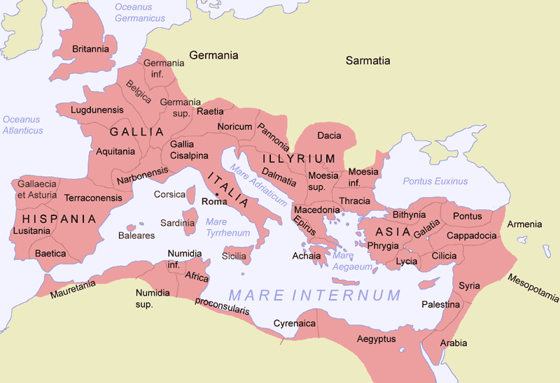
- Rulers were weak, ineffective, and corrupt
- There was no system for choosing a new emperor
- The empire was too big to govern well
- The army relied on permanent paid soldiers not temporary citizen volunteers
- Plague and famine weakened the population
- The empire relied too much on slavery

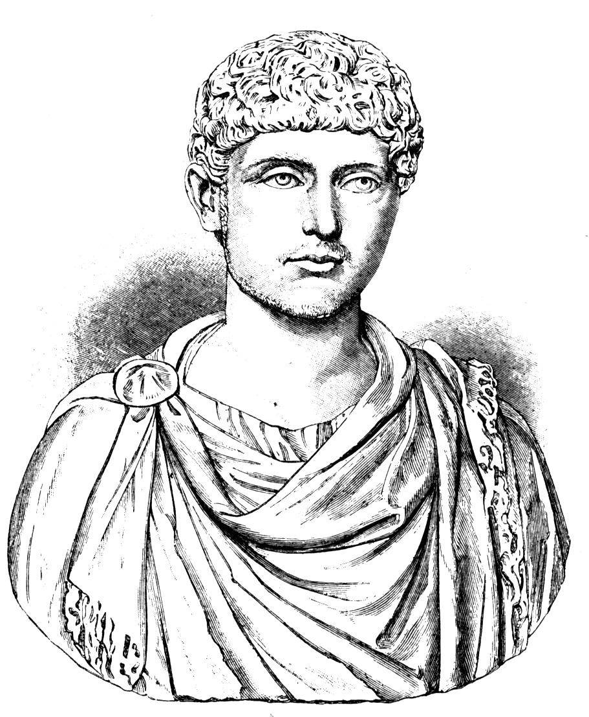
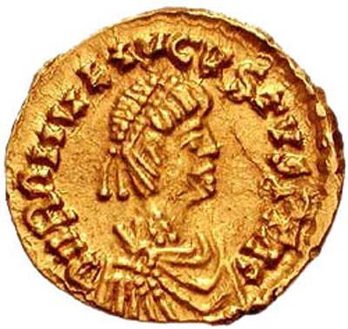
- People refused to pay taxes, and the government could not raise enough money
- Without enough money the government put less gold in its coins, money lost its value, and prices began to rise
- The cost of the army was too high, and it declined in size over time
- Attacks by outside invaders and lack of money for roads and bridges caused trade to decline
- The division of the empire into East and West caused a lack of unity

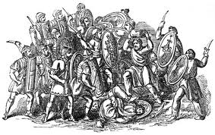

NO
You decide…
Was the Fall of Rome Inevitable?

Many historians believe the Romans could have solved the problems facing their empire.
Some possible solutions to Rome’s problems include the following:
- Develop a system for choosing a new emperor
- Restore power to the Senate and other parts of the government so more people would support the government
- End corruption by enforcing the law and punishing corrupt officials
- Increase the size of the army, possibly by asking all citizens to serve in times of emergency
- Strengthen the army by increasing pay
- Reinforce the empire’s borders against invasion
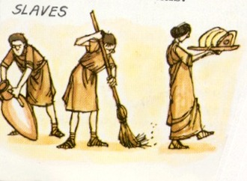
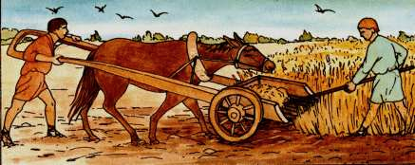
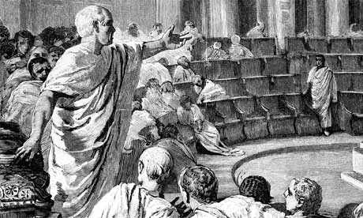
- Rebuild roads and bridges and build new ships to increase trade
- Develop a better communication system to help the government control the empire
- Force people to leave Rome and other cities and return to the countryside where more food and clean water were available
- Reduce the number of slaves or abolish slavery
- Break up large estates and give the land to former slaves, poor people in the cities, and members of the army as a reward for their loyalty
- Develop a new system of currency with money that held its value
