***Was the Fall of Rome Inevitable?***

***Problems and Solutions***

Read through the *“You Decide – Was the Fall of Rome Inevitable?”* information and arguments.

Choose any four different topics for which there are BOTH a problem and a solution, then match the problem and solution on the chart below.

|  |  |
| --- | --- |
| ***Problem*** | ***Solution*** |

|  |  |
| --- | --- |
|  |  |

|  |  |
| --- | --- |
|  |  |

|  |  |
| --- | --- |
|  |  |

|  |  |
| --- | --- |
|  |  |

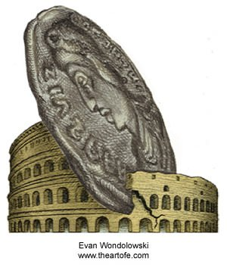  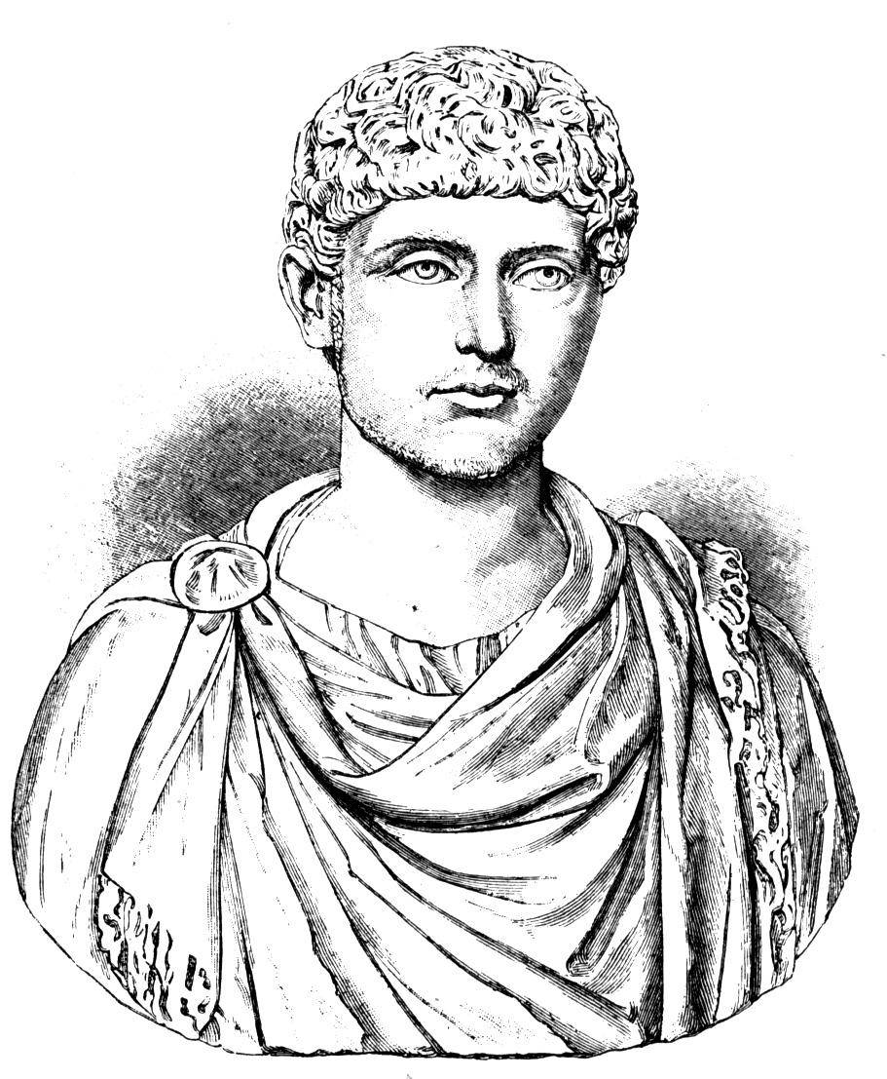

*Continued on the back*

Which one of the four problems you have chosen do you think would have been the *easiest* to correct?

Identify the problem, then identify the solution and explain **why** it would be easy. Write your response in complete sentences.

________________________________________________________________________________________________________________________________________________________________________________________________________________________________________________________________________________________________________________________________________________________________________________________________________________________________________________________________________________________________________________________

____________________________________________________________________________________

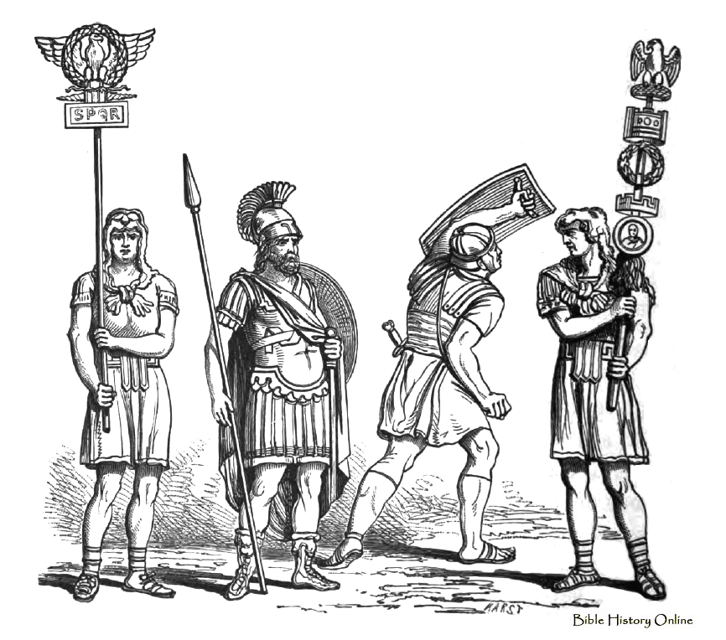 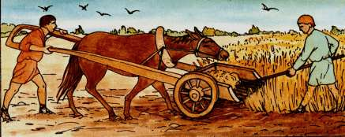

Which one of the four problems you have chosen do you think would have been the *most difficult* to correct? Identify the problem then identify the solution and explain **why** it would be difficult. Write your response in complete sentences.

________________________________________________________________________________________________________________________________________________________________________________________________________________________________________________________________________________________________________________________________________________________________________________________________________________________________________________________________________________________________________________________

____________________________________________________________________________________

***Your final opinion – Was the fall of the Roman Empire inevitable?*** Choose ONE side of the argument and provide two different details to *briefly* explain your reasoning. Use complete sentences.

____________________________________________________________________________________________________________________________________________________________________________________________________________________________________________________________________________________________________________________________________________________________________________________________________________________________________

____________________________________________________________________________________