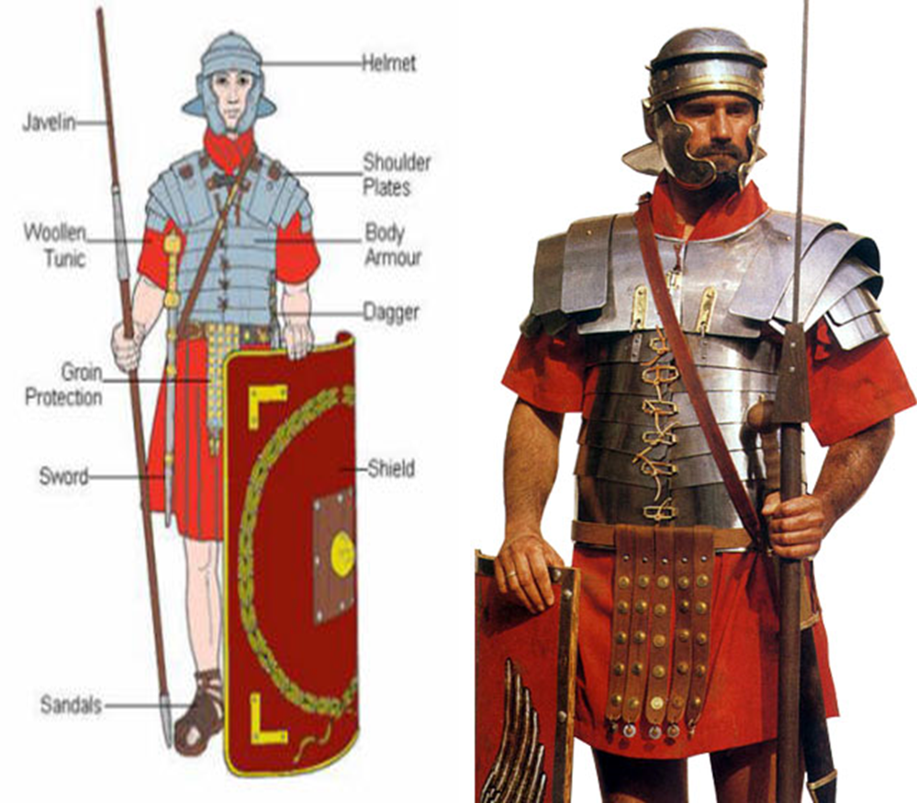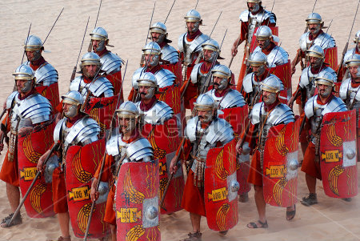The Roman Army

They fought with short swords, daggers for stabbing, and a long spear for throwing. They also carried a shield for protection as well as wearing armor.

Roman soldiers were trained to fight well and to defend themselves. If the enemy shot arrows at them, they would use their shields to surround their bodies and protect themselves.

Organization of the Army

The army was organized in a very simply way:

800 Legionnaires (Roman citizens who were in the army) would form a Legion.

The Legion would be split into Centuries (80 men) controlled by a Centurion.

The Centuries would then be divided into smaller groups with different jobs to perform.

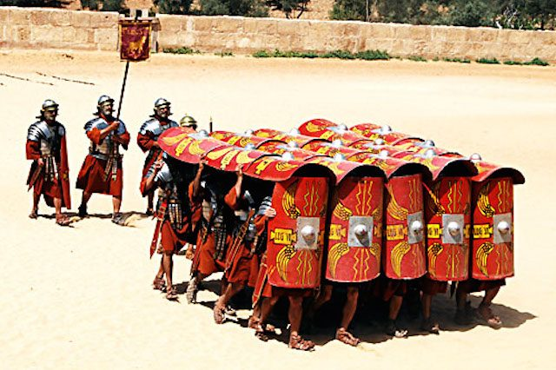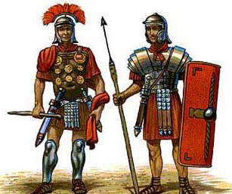

1. Why was the Roman Army important to the Roman Empire?

2. How was the Roman Army organized?

3. How many men were in a Century?

4. Which weapons were used by Roman soldiers?

5. How did the Roman Army help to build the Roman Empire?

6. What were some of the advantages of being a Roman soldier?

7. What were some of the disadvantages of being a Roman soldier?

8. How did soldiers protect themselves when arrows were shot at them?

Extension

Draw a diagram of the Roman soldier’s uniform and weapons.

Roman soldiers had to be tough. They were expected to march up to 20 miles a day, in line, wearing all their armor and carrying their food and tents.

The Romans managed to conquer so many countries because they had such a good army. The Emperor used the army to protect Rome and to control the people it had conquered. Some soldiers were away from their families for long periods of time.

When a soldier had served for 25 years, he could become a citizen of Rome.